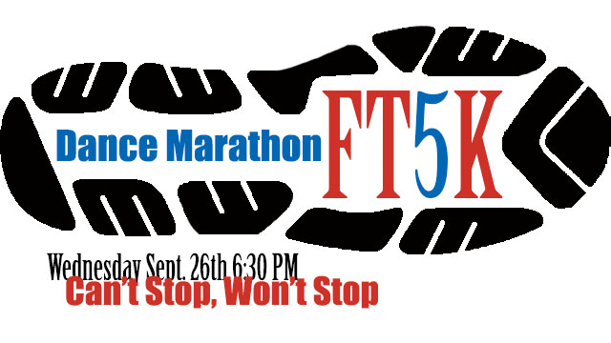
When: Registration at 6 PM, Race begins at 6:30
Location: Saint Mary’s College, Softball fields (turn right off of Douglas Rd onto Madeleva Dr - the softball fields will be on the right)
Cost: $12 registration fee (includes a T-shirt)

In order to get a shirt you must register and send cash or check to Saint Mary’s College by Monday, September 17.

FTK, For The Kids!

FT5K Name:__________________________________________ Saint Mary’s College
Dance Marathon
Address:________________________________________ 244 Student Center
_________________________________________ Notre Dame, IN 46556
T-Shirt Size (unisex S - XL): ____________

Registration fee: $12
*Please make checks payable to Saint Mary’s College

All funds go to Saint Mary’s Dance Marathon, which directly supports Riley Hospital for Children in Indianapolis by engaging our community and campus, supporting our Riley families, and celebrating life’s victories and new hope. This is a fun run to support a great cause; runners will be given an approximate time with stopwatches as they cross the finish line but there are no time chips or official online race results.

