HOUSING FOR SEMINAR PARTICIPANTS
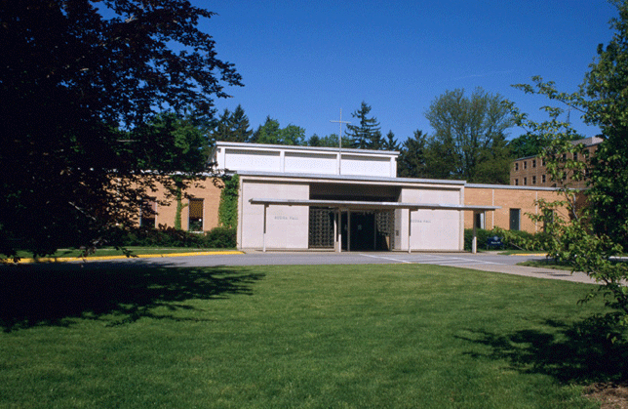
Regina Hall is a college residence hall in close proximity to the campus dining facilities. Regina houses the chapel where we will gather for Eucharist and optional Monday evening prayer as well as lounges for social gatherings. The hall has single rooms, each with a closet and sink. The rooms are not air-conditioned but window fans are provided. Laundry facilities are available in the basement. Cost: $35 per person per day (June 9-11).
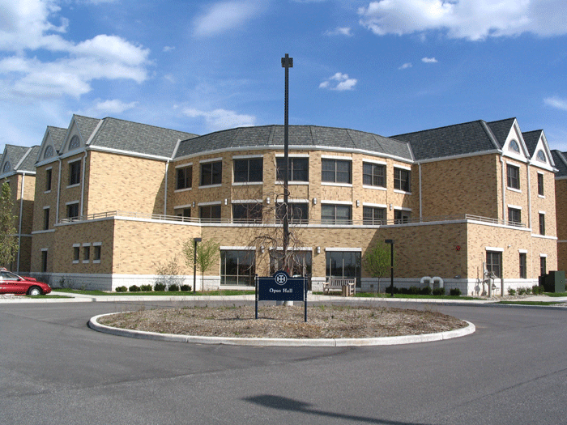

Opus Hall is an air-conditioned, apartment style residence hall with 24 units. Each unit has a kitchenette (without utensils, dishes, pots, and pans), a living room, 2–4 private bedrooms, and semi-private bathrooms. Laundry facilities are available in the basement. Opus is walking distance from the campus dining facilities. For those who do not want to walk, college staff will be providing transportation between Opus and seminar venues on golf carts. You may request to be housed with specific suite-mates or these will be assigned if you are traveling alone. The Opus apartments fill quickly so register early if this is your housing preference. Cost for a bedroom in a suite: $60 per person per day (June 9-11).

In both Opus Hall and Regina Hall, 1 set of linens is included. This includes a pillow, pillow cover, bed sheets, blanket, and bath towels.

The Inn at Saint Mary’s borders the college campus. It is walking distance from the campus dining facilities. For those who do not want to walk, college staff will be providing transportation between the Inn and seminar venues on golf carts. Information on the accommodations at the Inn can be found on their website: http://www.innatsaintmarys.com/. Rooms are available at a seminar discount rate of $111 per person per night (excluding taxes). Make room reservations directly with the Inn at 574-232-4000.

For more information on housing options, contact Kathy Guthrie at (574) 284-4636 or kguthrie@saintmarys.edu.

